Table of Contents

1. Test Scope: 2

2. Test Approach: 2

2.1 Process of Testing: 2

2.2 Testing Levels: 2

2.3 Roles and Responsibilities: 3

2.4 Types of Testing: 3

3. Test Environment: 3

4. Testing Tools: 3

5. Risk Analysis: 3

6. Review and Approvals 3

# Test Scope:

The purpose of this document defines the overall testing strategies and provide an integrated view of the project test activities involved in the Acme Airlines web portal for flight bookings.

# Test Approach:

## Process of Testing:

The testing is founded on the following principles:

* Test the critical path item first. The testing effort will be sequenced based on critical functionality. Risk assessment will be evaluated on an ongoing basis to understand third-party dependencies and the critical test factors. Test execution will be ordered by priority and the execution of each stage may be adjusted for dependencies or critical defects.
* Test early. It is far less costly to fix low level errors earlier in the system’s development life cycle rather than later.
* Identify and prioritize each defect during test execution.

## Testing Levels:

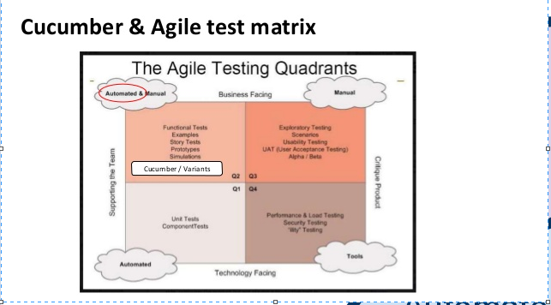

## Roles and Responsibilities:

Unit testing will be done by developers. Component, Integration, API, functional and System testing will be done by manual automation test engineer. Assumption here is that all functional tests cannot be automated. There will be dedicated sprint for exploratory testing.

## Types of Testing:

Below type of testing will be done in Agile development:

Unit Testing

Component Testing

Integration Testing (Integration testing with Global Dist. System and CBA payment Gateway)

System testing

Dedicated sprints for formal verification cycles.

# Test Environment:

Test environment will have the same code base as the production environments, or real data as required, for the execution of the tests.

# Testing Tools:

Selenium and Cucumber are required to write automation script for component and functional testing. Whereas manual tests will be maintained in TestRail tool.

Rest-Assured API with cucumber will be used to test integration with Third-party APIs.

Defects will be tracked using Jira. The relevant information and tracking for the resolution of defects will be logged in Jira.

# Risk Analysis:

There might be conflict with third party system. To mitigate this, get the confirmation from the supplier that there will be no impact to other tools.

# Review and Approvals

All these activities are reviewed and sign off by the business team, project management, development team, etc.